**Lab 1 Web GIS Introduction**

**-Answers-**

**REMINDER: DO NOT CHANGE THE FORMAT OF THIS DOCUMENT. ALTER SPACING BETWEEN QUESTIONS AS NECESSARY.**

**/42**

**Name: Jacob Dietrich** **Date: 8/29/2021**

1. **Provide the following information for your selected web map (2D)**
2. **Web map name (1)**

Modern Antique Map

1. **Brief map description (1)**

“This web map provides a customized vector layer for the world symbolized with a unique antique styled map, with a modern flair –including the benefit of multi-scale mapping.

**4) A screenshot of the map shown in the map viewer (1)**

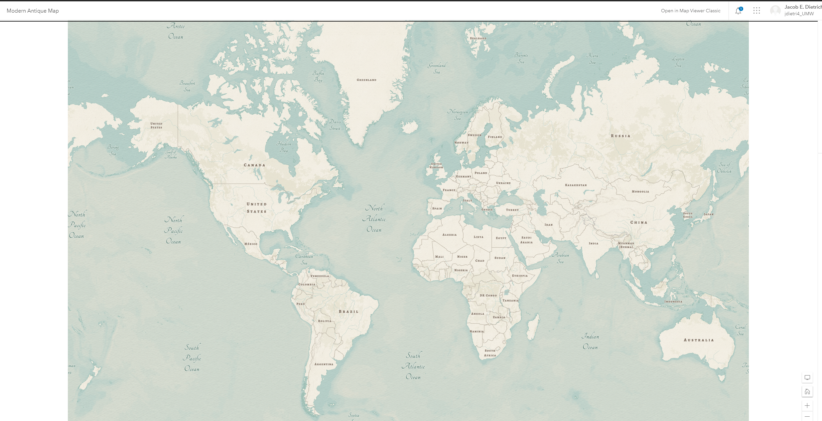

1. **Provide the following information for your selected web scene (3D)**
2. **Web scene name (1)**

Mountain Biking in Bavaria

1. **Brief scene description (1)**

This 3D Webscene shows the 2 Open Data layers Mountainbike Trails and Bike Tour Routes (Bayernnetz) draped over the Esri World Imagery Basemap and the Esri Globe.

1. **A screenshot of the scene shown in the scene viewer (1)**

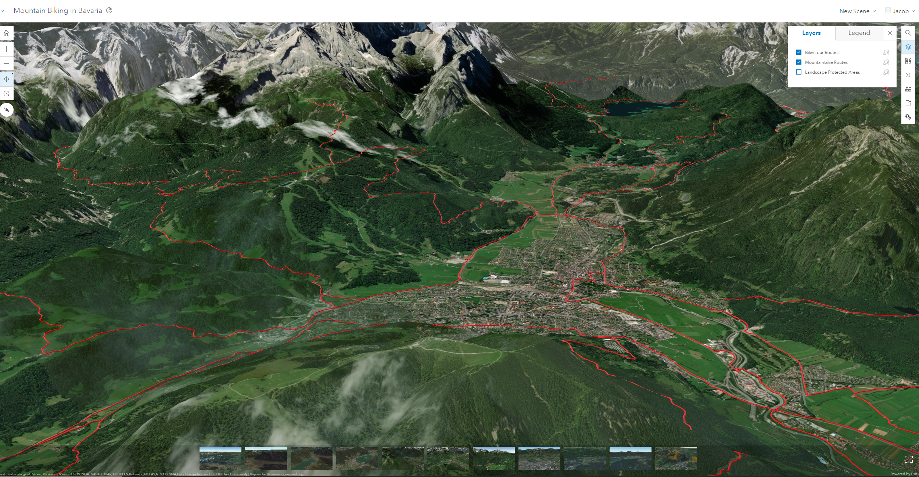

1. **Provide the following information for your selected web app**
2. **Web app name (1)**

World War I: The Role of Canadian Women

1. **Brief app description (1)**

In this Esri Canada activity, you will explore the changing role of Canadian women, including their contribution on the home front and overseas during World War I through primary source documents, such as photographs, letters, paintings, and advertisements.

1. **A screenshot of the app shown in the web browser (1)**

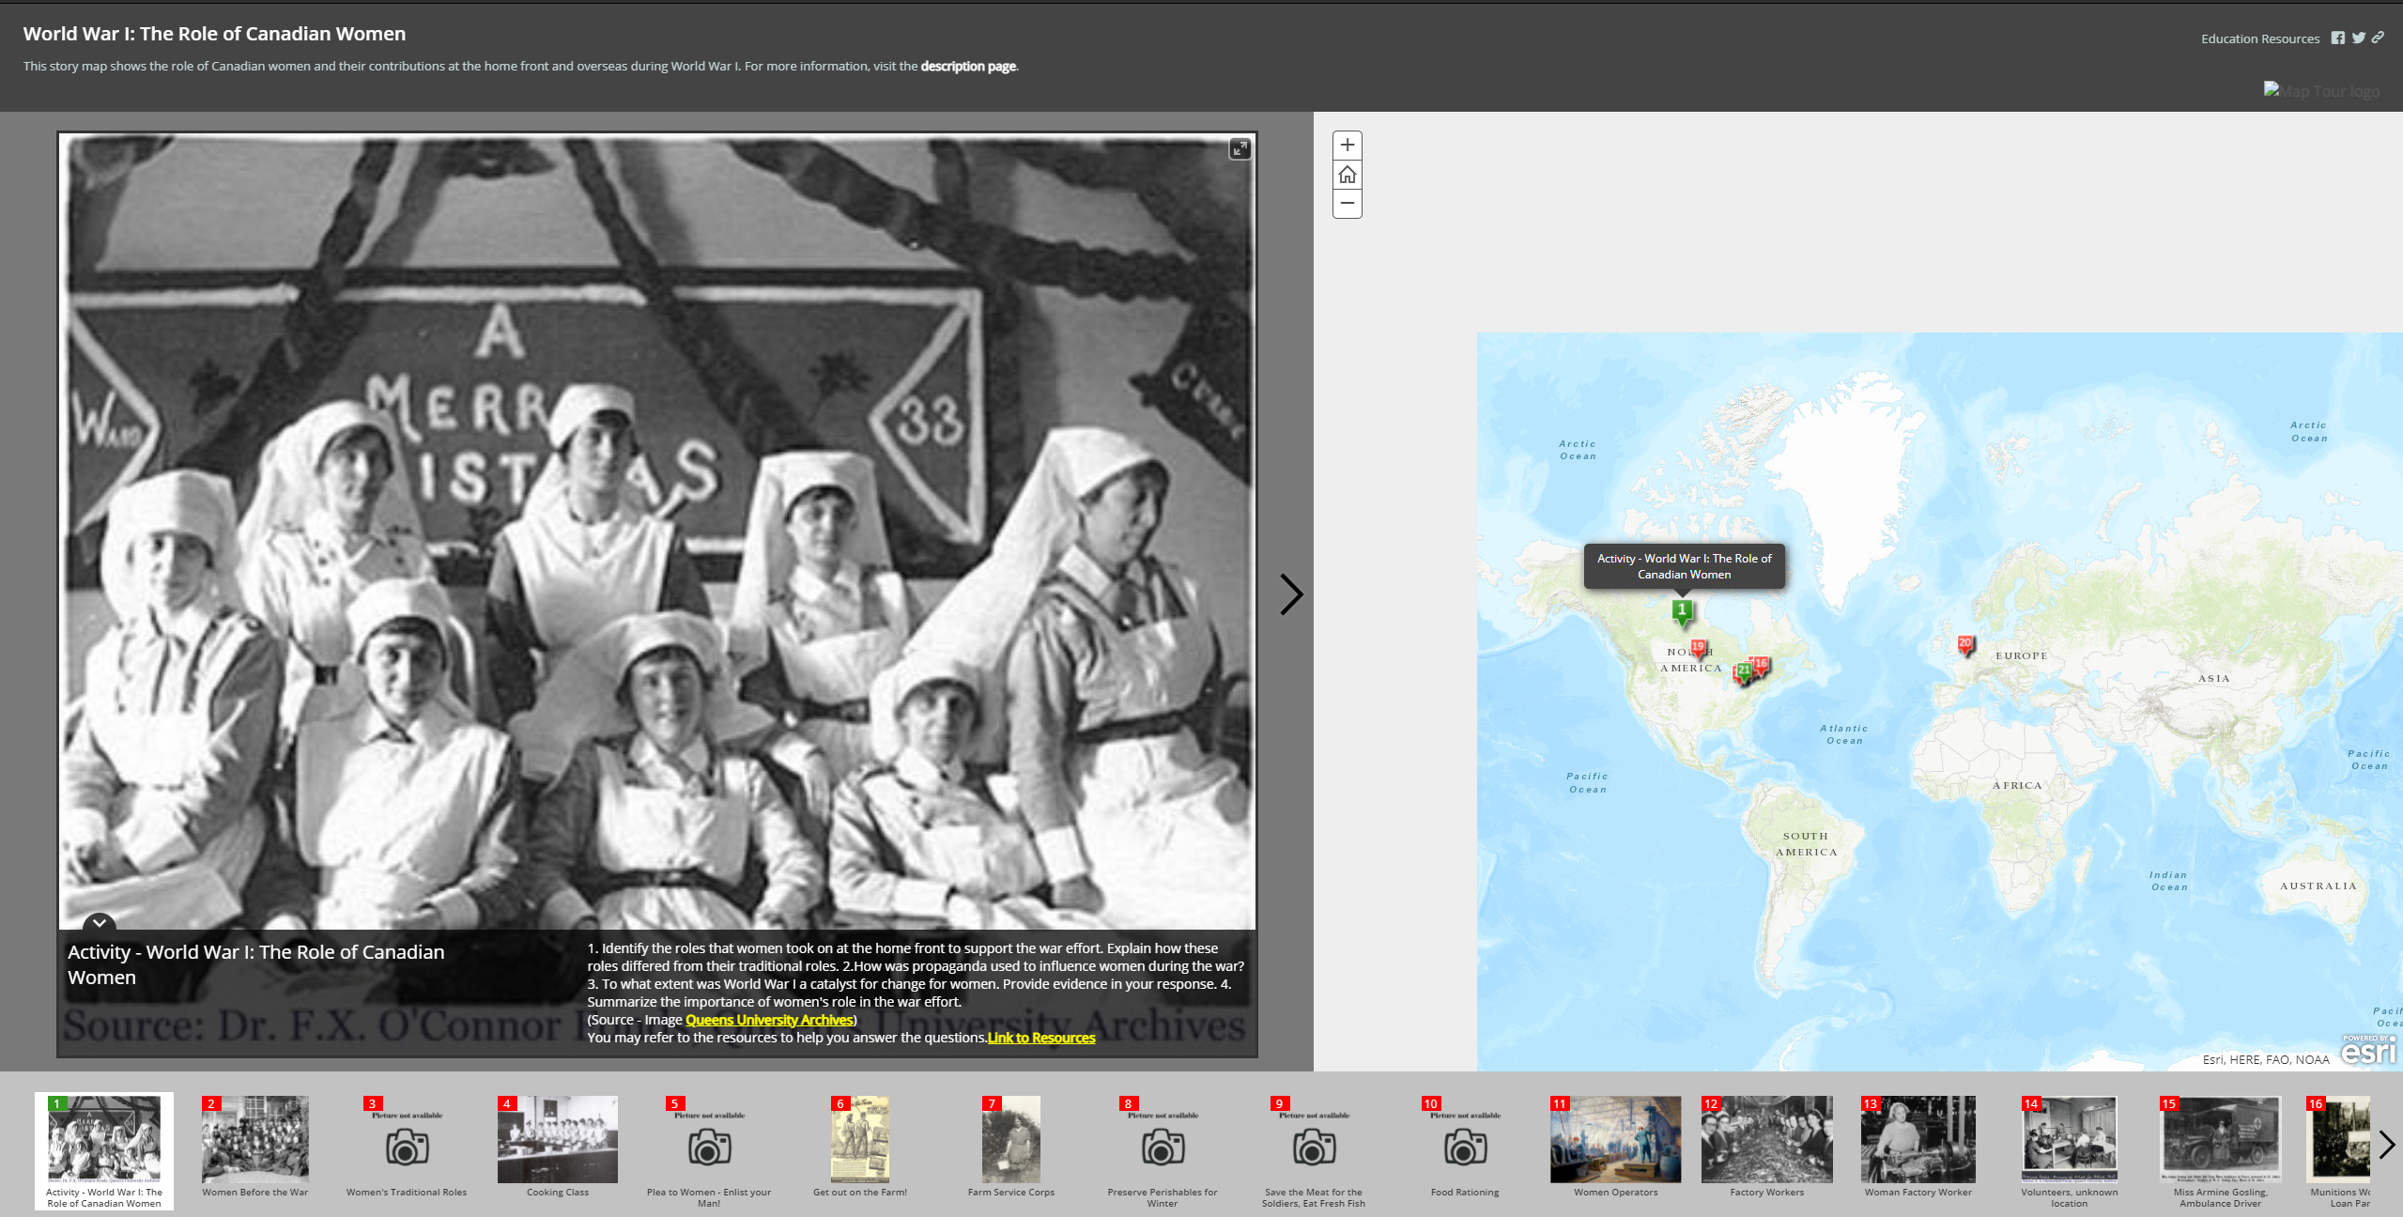

1. **Brief descriptions of the three components in this web app**
2. **Basemap (1)**

**The basemap includes pins placed mainly throughout Canada, as well as in Europe. Each pin has an attached picture and caption.**

1. **Other map layer(s) (1)**

**There are no other map layers to this app aside from the geolocated pins placed at relevant locations.**

1. **Major tools (excluding map navigation tools) (2)**

**Aside from map navigation tools, there looks to be no other tools used for this app.**

1. **What are the differences among Web maps, Web scenes, and Web apps? (3)**

Web maps seem to be just that, a non-interactive map that provides information through the visuals, scope, and navigational tools. Web scenes seem to be similar to Web maps, but to provide the viewer with more finely detailed information using 3D modeling and different than top-down perspectives. Web apps seem to be interactive Web maps used for storytelling and sequences of information relevant to the scope of the map.

1. **Which default role(s) of ArcGIS Online can create and share maps and apps? Which default role(s) can publish hosted web layers? (2)**

Users, Publishers, Facilitators, and Administrators can create and share maps and apps.

Publishers, Facilitators, and Administrators can publish hosted web layers.

1. **Provide the URL of your map tour app for review. (22)**

https://umw.maps.arcgis.com/home/item.html?id=58d67c0b681f417fac6e93f7b284557d

1. **Explain your consideration of the selection of the base map in your app. (1)**

I chose the default base map for my app because of a few reasons. Firstly, topography is not relevant for the information being shared. Secondly, the points of interest shared are easily navigable to because of their relation to specific streets and landmarks, which appear on the default base map. Lastly, the default base map helps direct people due to the map already having some of the names of the places such as Chancellorsville battlefield on the map.

1. **When your app is browsed on your smart phone with portrait (i.e., vertical) orientation, will the map display on the same page with the photo? (1)**

**No, the map will display on a different tab than the photo. The map and photos will also display on a different tab than the introduction tab.**